HANU Training Management System

Use-Case-Realization Specification: View Tuition Fee

Version <1.0>

*[Note: The following template is provided for use with the Rational Unified Process. Text enclosed in square brackets and displayed in blue italics (style=InfoBlue) is included to provide guidance to the author and should be deleted before publishing the document. A paragraph entered following this style will automatically be set to normal (style=Body Text).]*

*[To customize automatic fields in Microsoft Word (which display a gray background when selected), select File>Properties and replace the Title, Subject and Company fields with the appropriate information for this document. After closing the dialog, automatic fields may be updated throughout the document by selecting Edit>Select All (or Ctrl-A) and pressing F9, or simply click on the field and press F9. This must be done separately for Headers and Footers. Alt-F9 will toggle between displaying the field names and the field contents. See Word help for more information on working with fields.]*

Revision History

| **Date** | **Version** | **Description** | **Author** |
| --- | --- | --- | --- |
| December 04, 2021 | 1.0 | Final | Lai Hanh Van |
|  |  |  |  |
|  |  |  |  |
|  |  |  |  |

Table of Contents

1. Introduction 2

1.1 Purpose 2

1.2 Scope 2

1.3 Definitions, Acronyms, and Abbreviations 2

1.4 References 2

1.5 Overview 2

2. Flow of Events—Design 2

3. Derived Requirements 2

Use-Case-Realization Specification: View Tuition Fee (Student)

# Introduction

## Purpose

This Use-case Realization Specification gives an overview of how the View Tuition Fee use-case is realized in terms of collaborating items within the design model.

## Scope

This document only applies to the View Timetable use-case, within the EDMS of HANU.

## Definitions, Acronyms, and Abbreviations

User – a person who uses the system, can be a student or teacher.

Administrator - a person who is responsible for the activities in the system.

EDMS - Educational Management System

HANU – Hanoi University

## References

[1] ***Use-case Specification: View Timetable***, Lai Hanh Van, December 04, 2021, HANU Training Management System.

## Overview

The next part contains diagrams (sequence and class diagrams) describing how the View Tuition Fee use case is realized in terms of collaborating objects. The third component contains class diagrams with relationships that aid in the execution of the use case. The final section looks at various use-case realization requirements that were not included in the design model but must be handled during implementation, such as non-functional requirements.

# Flow of Events—Design

## Sequence diagram

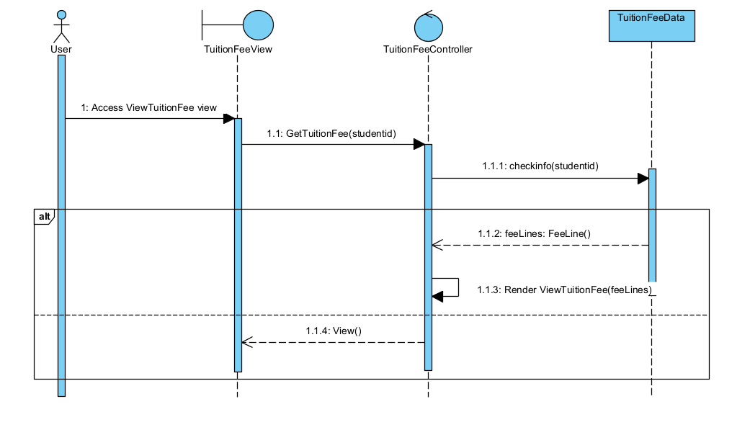

## Class diagram

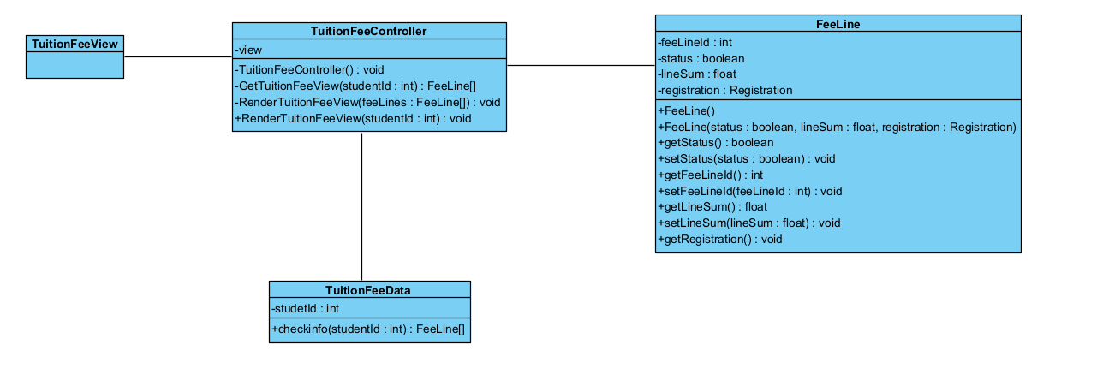

# Derived Requirements

There are no special requirements.